[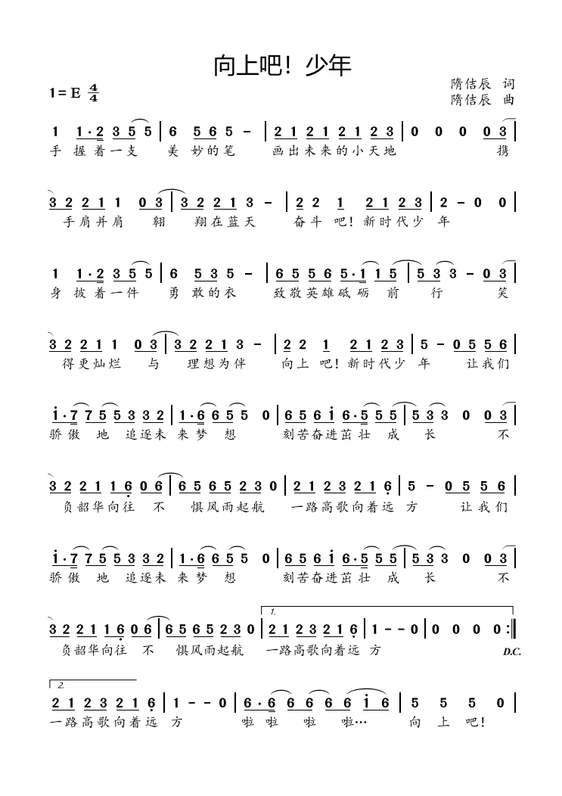](http://cms.k618.cn/webpic/W0202206/W020220602/W020220602547576682492.png)

[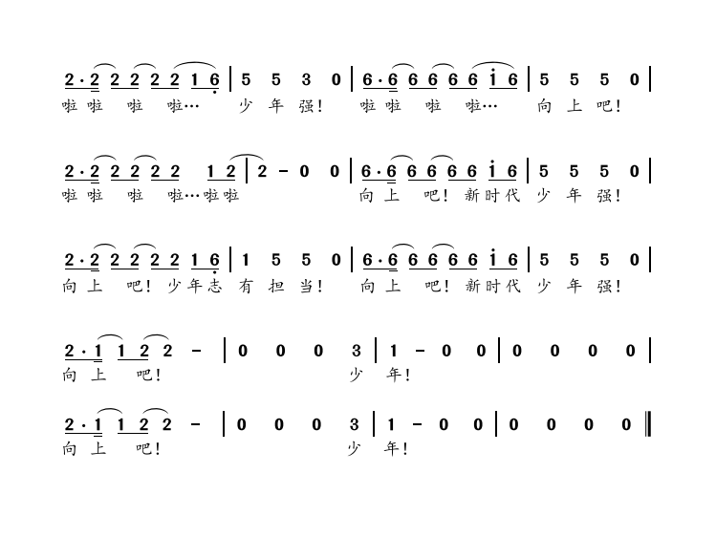](http://cms.k618.cn/webpic/W0202206/W020220602/W020220602547576713133.png)