[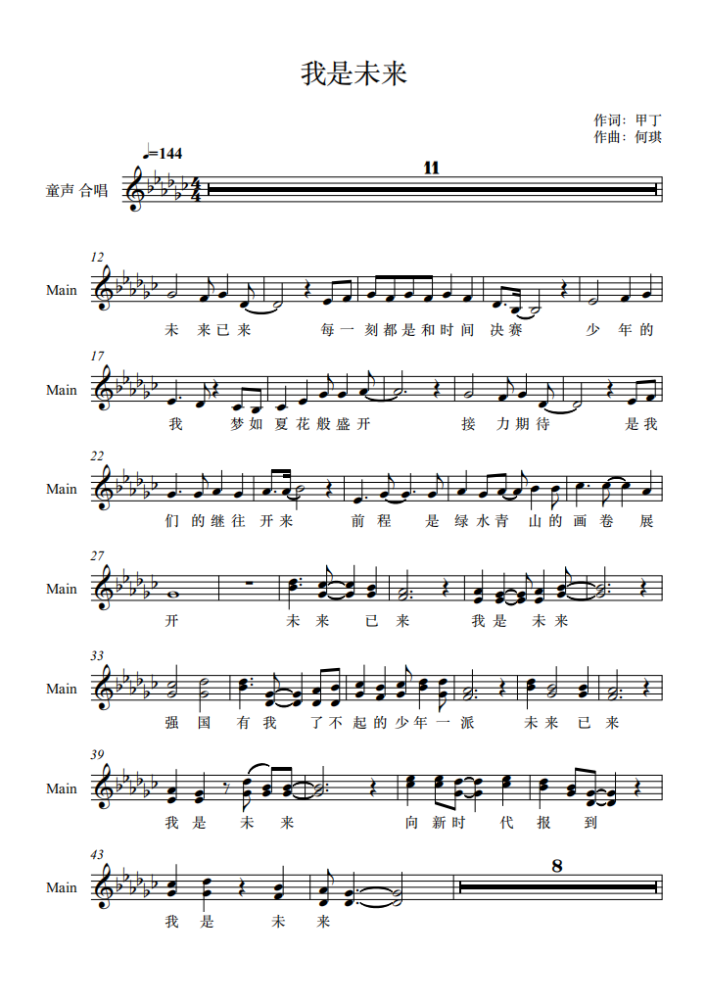](http://cms.k618.cn/webpic/W0202206/W020220602/W020220602380739294347.png)

[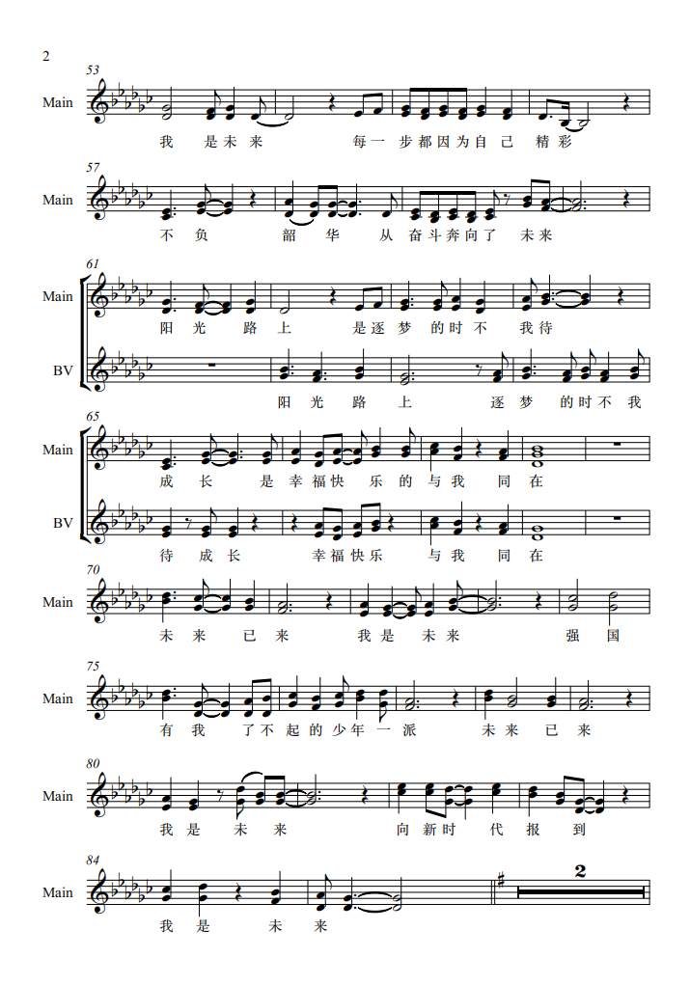](http://cms.k618.cn/webpic/W0202206/W020220602/W020220602380739331362.png)

[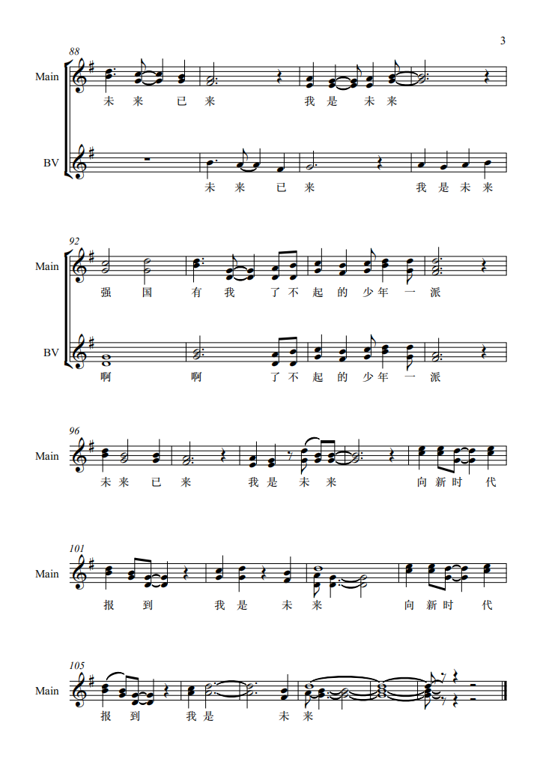](http://cms.k618.cn/webpic/W0202206/W020220602/W020220602380739353001.png)