[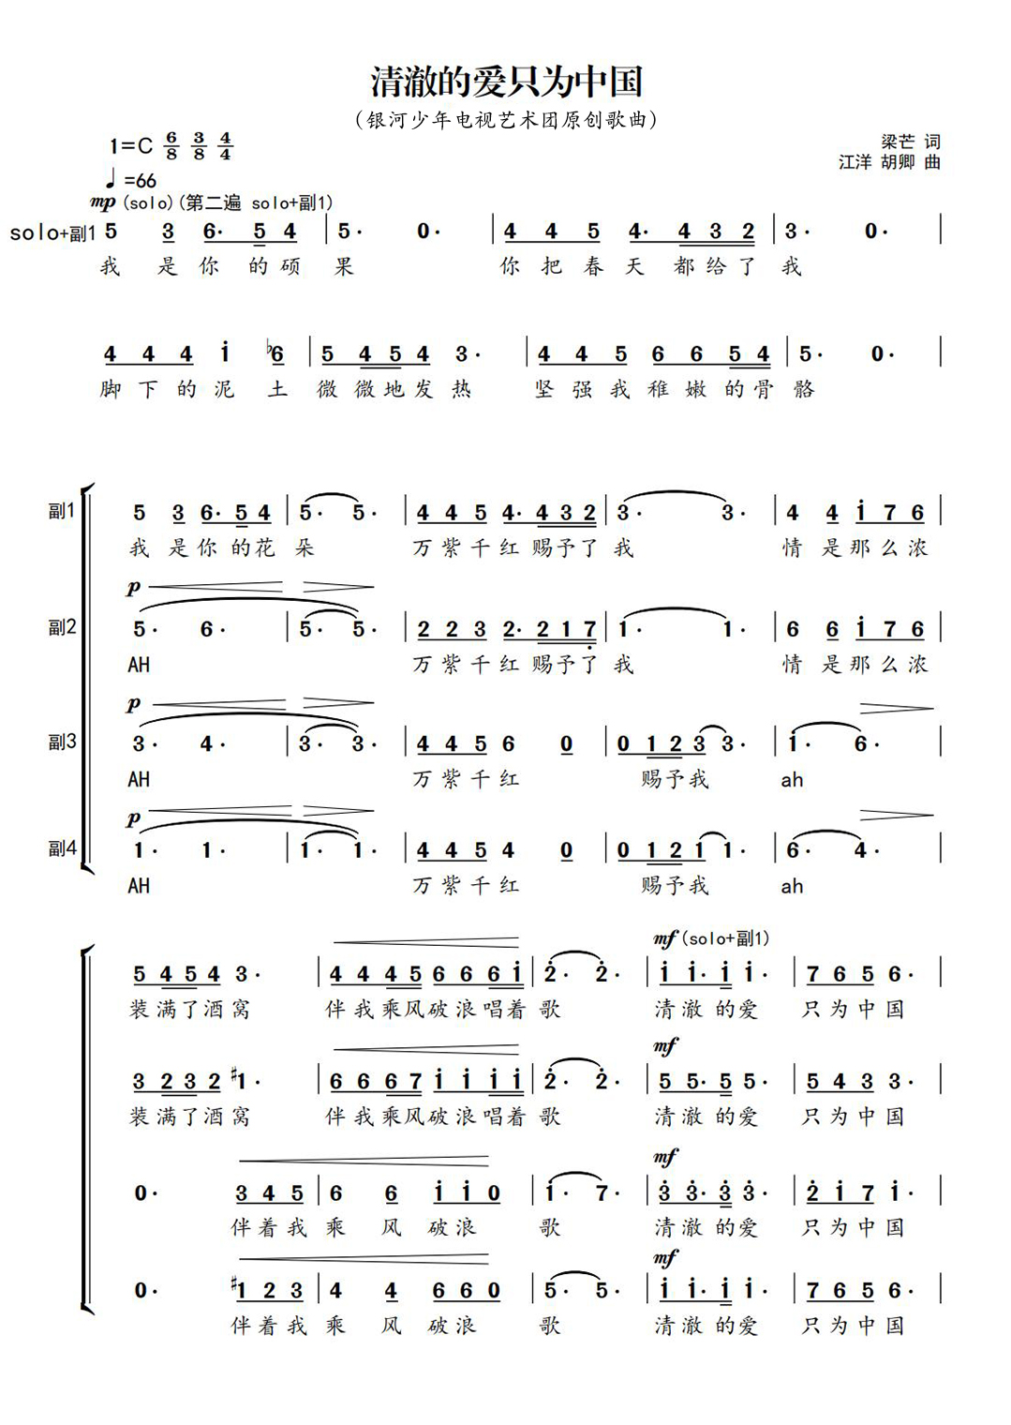](http://cms.k618.cn/webpic/W0202108/W020210803/W020210803601868525574.jpg)[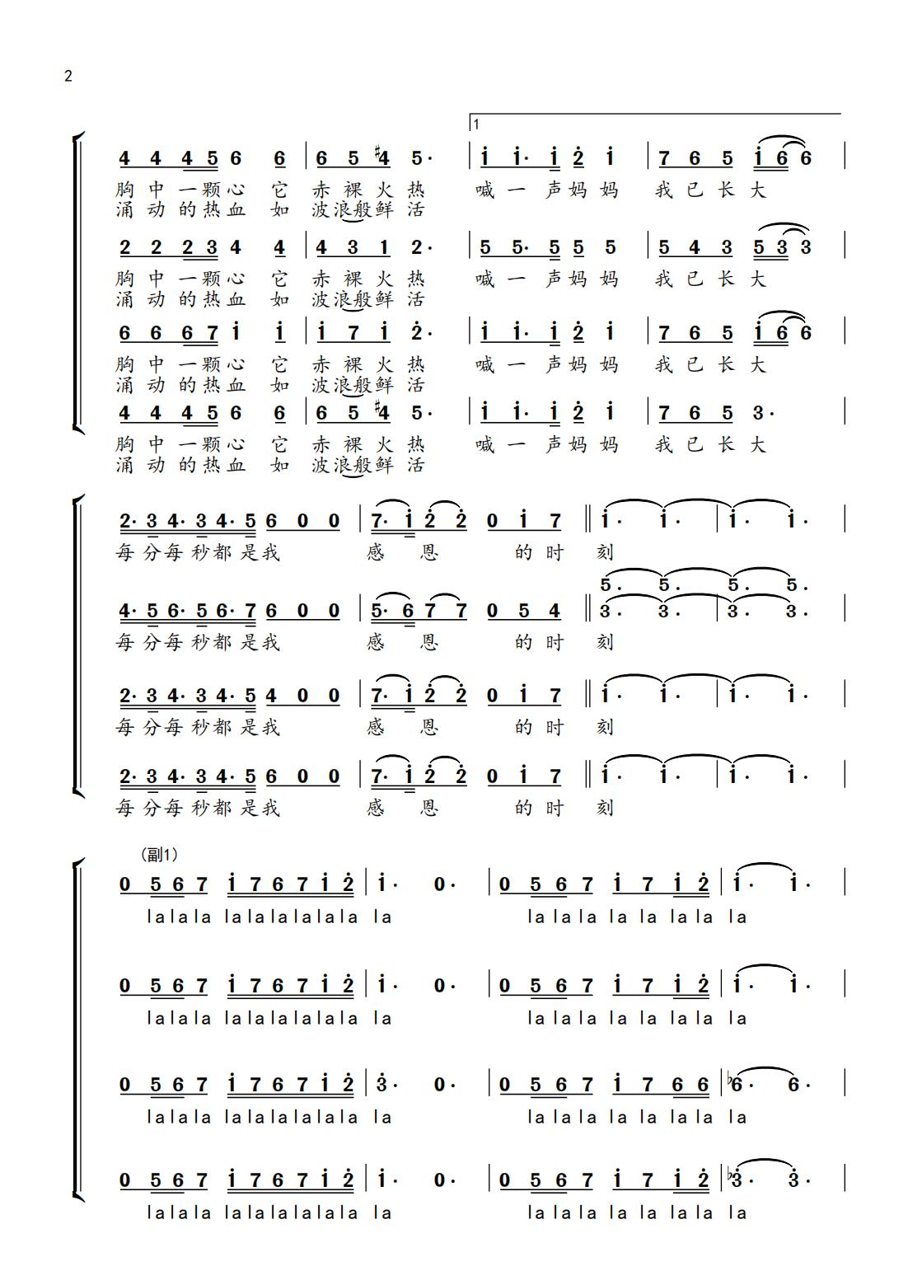](http://cms.k618.cn/webpic/W0202108/W020210803/W020210803601868589976.jpg)

[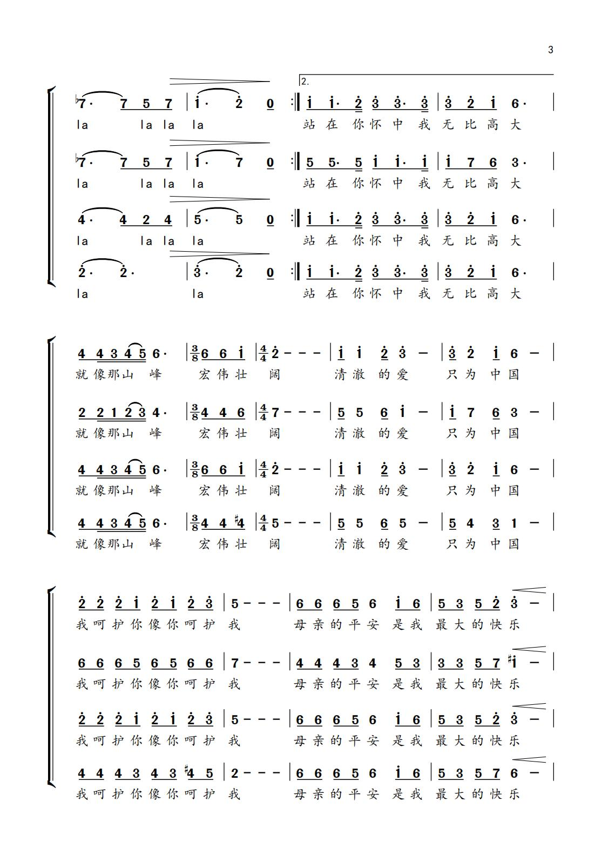](http://cms.k618.cn/webpic/W0202108/W020210803/W020210803601868911636.jpg)

[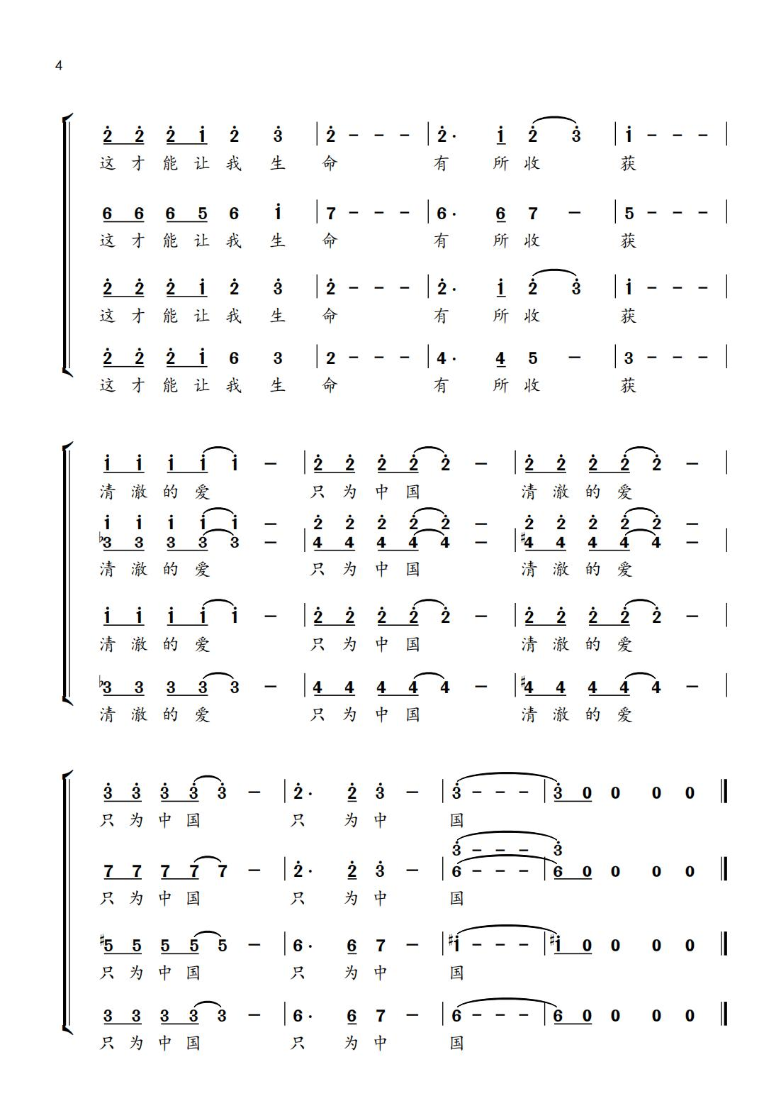](http://cms.k618.cn/webpic/W0202108/W020210803/W020210803601868938241.jpg)